Proper Adjectives

🔹 What Are Proper Adjectives?
# Source: AI Source: Provided by: [Data Path: Persons Table -> ID Column: 1, Name_En Column: Motasem Essam] -> From: [Chatgpt (GPT-4-turbo)] on [7/27/2025]
Proper adjectives are adjectives that are formed from proper nouns (names of specific people, places, or things).
They describe nouns by showing origin, nationality, culture, or association with something specific.

✅ Examples of Proper Adjectives
# Source: AI Source: Provided by: [Data Path: Persons Table -> ID Column: 1, Name_En Column: Motasem Essam] -> From: [Chatgpt (GPT-4-turbo)] on [7/27/2025]
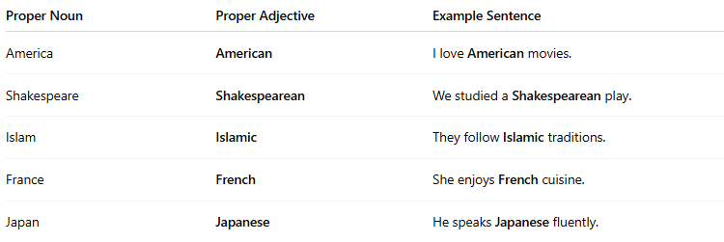
Proper Noun | Proper Adjective | Example Sentence
America | American | I love American movies.
Shakespeare | Shakespearean | We studied a Shakespearean play.
Islam | Islamic | They follow Islamic traditions.
France | French | She enjoys French cuisine.
Japan | Japanese | He speaks Japanese fluently.

🧠 Key Features
# Source: AI Source: Provided by: [Data Path: Persons Table -> ID Column: 1, Name_En Column: Motasem Essam] -> From: [Chatgpt (GPT-4-turbo)] on [7/27/2025]
- Always capitalize proper adjectives (just like proper nouns).
✅ They live in an Italian village.
❌ They live in an italian village. (incorrect)
- They tell us “What kind?” of noun.
A Buddhist temple → What kind of temple? Buddhist.

📚 More Examples
# Source: AI Source: Provided by: [Data Path: Persons Table -> ID Column: 1, Name_En Column: Motasem Essam] -> From: [Chatgpt (GPT-4-turbo)] on [7/27/2025]
- Christian holidays
- Chinese medicine
- Marxist ideas
- Victorian fashion

